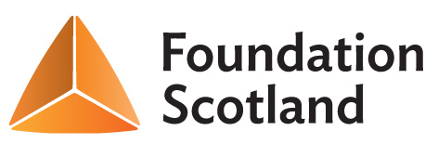

Micro-Grants Application Form (Up to £250)

Contact Details:

Name of group or individual applying

Main contact

Address
Postcode

E-mail Telephone (main)

About you and / or your organisation:

Are you an unconstituted group? Y / N

Details of Micro-Grant Requested:
Please provide details of your project – what activities will you carry out, who are the beneficiaries?

How much are you requesting? (Up to £250)

What will the micro-grant be used to pay for? (Please provide a cost breakdown)

Declaration: I certify that the information contained in this application is correct, and that I am authorised to make the application on behalf of the above group / individual.

Name (please print):

Signature: Date:

Please send your completed applications to your local Community Council.

